Auto Indoor Hydroponic Fodder Grow Chamber

ABSTRACT

Hydroponics is changing the agriculture industry slowly. The ability to grow indoors brings another dimension to agriculture. Here we develop a fully automated mini fodder grow chamber to grow fodder indoors within a week.
The system makes use of a temperature controlled chamber to maintain a cool air flowing environment along with grow lights to simulate sunlight along with water and moisture monitoring to ensure proper indoor grow conditions for a good growth.
The system makes use of arduino controller interfaced with a keypad to get user inputs on the water change and flow, indoor optimum temperature parameters. The system then monitors the indoor conditions using water sensor, moisture and temperature sensor to always keep a tap on indoor conditions.
The system uses the motor to ensure water level is maintained using the pump motor to adjust water level, the moisture and temperature sensors are monitored to maintain best temperature and moisture conditions for growth. The indoor artificial sunlight is switched on and off as per specified by the user automatically.
This entire operation is efficiently managed by an arduino controller to ensure the entire process is repeated regularly without fail. The system also sounds an alarm if the water tank runs out of water. Thus the system ensures automatic indoor fodder grow system using arduino controller.

BLOCK DIAGRAM
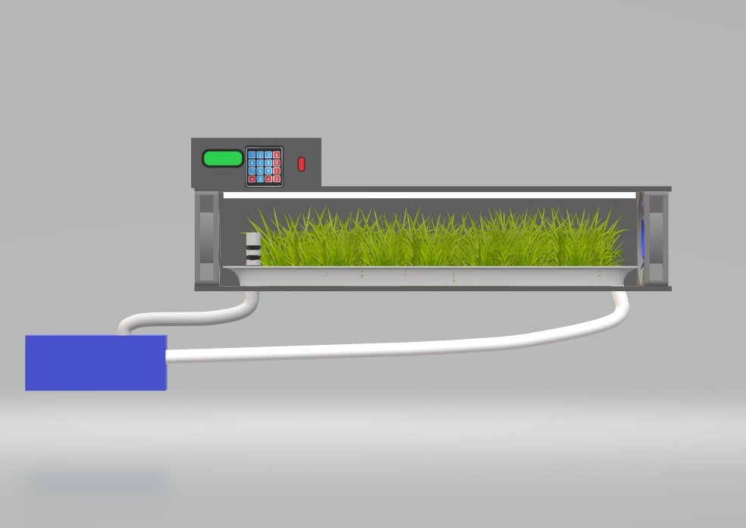
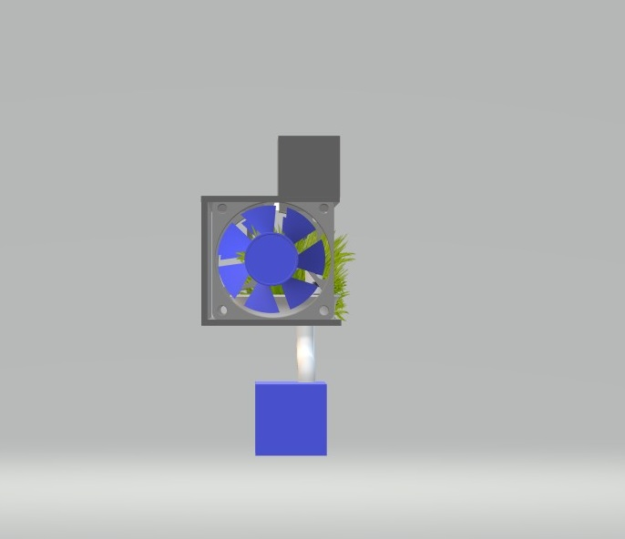
Hardware Specifications
- Arduino
- Water Sensor
- Moisture Sensor
- Temperature Sensor
- Artificial Solar Light
- Pump Motor
- LCD Display
- Keypad
- LED’s
- Switches
- Holding Tray
- Water Tank
- Pipes and Tubes
- Glass Door

- Resistors
- Capacitors
- Diodes
- Transistors
- Outer Frame
- Mounts and Fittings
- Supporting Frame
- Screws & Joints
Advantages
- Easy to Grow Plants Indoors
- No Need of sunlight
- No Need of Soil
- Auto Temperature Control
- Automatic Water Level Check
Disadvantages
- Requires Electricity
- Requires humans to Fill Water in Tank

